**Exercise 01 Create Table Persistence and Generate Data**

**Step 1 Create ABAP Package**

Open ABAP Development Tools (ADT) and select your ABAP Cloud Project you created in [Create an SAP BTP ABAP Environment Trial User](https://developers.sap.com/tutorials/abap-environment-trial-onboarding.html).

Right-click on ZLOCAL and select New > ABAP Package.

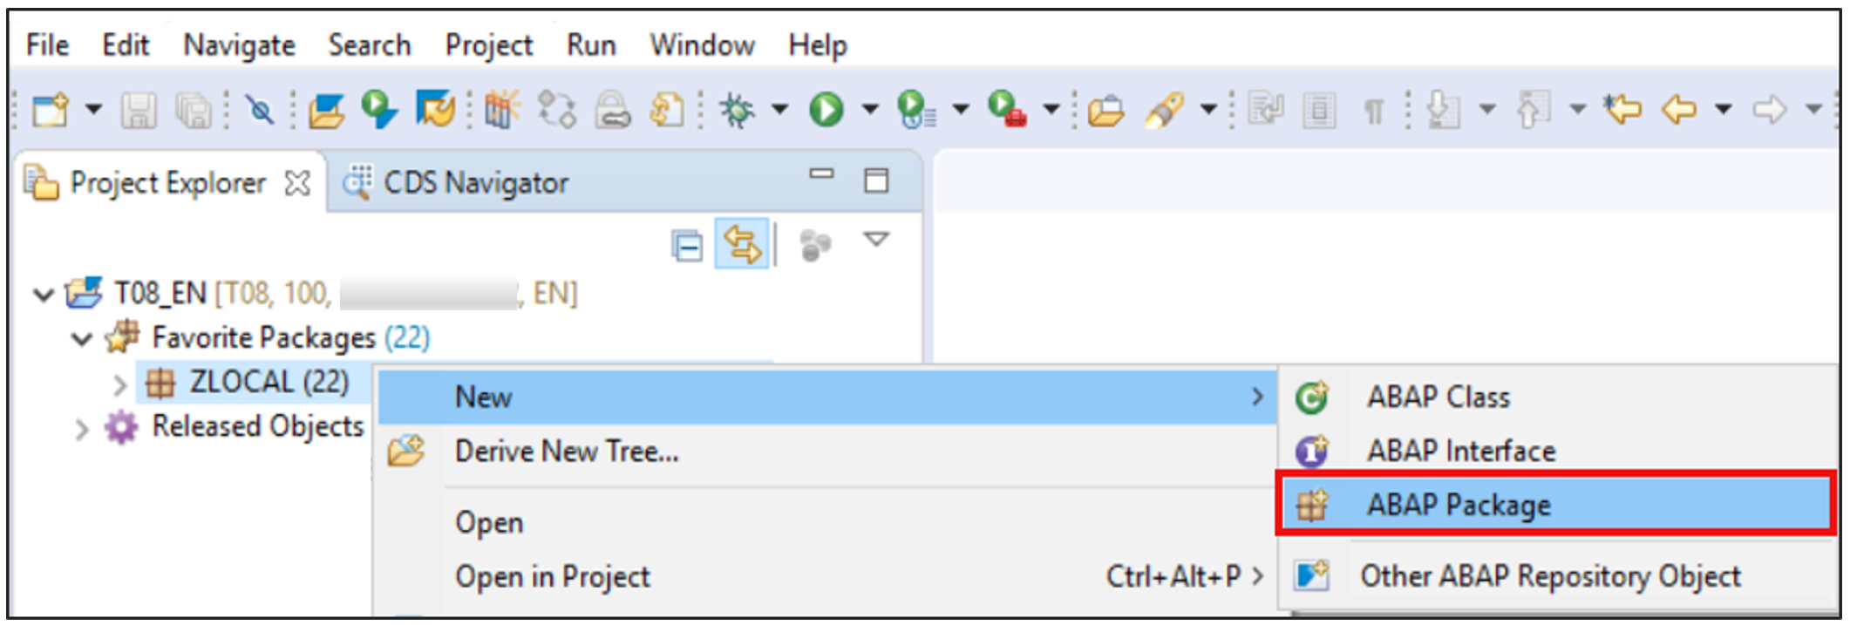

1. Create a new ABAP package:
   * Name: Z230511_APP_XXX
   * Description: Package for travel XXX
   * Superpackage: Y----------ABAP_DEMO_EXERCISE
   * Check Add to favorite packages.

Use your number instead of XXX.

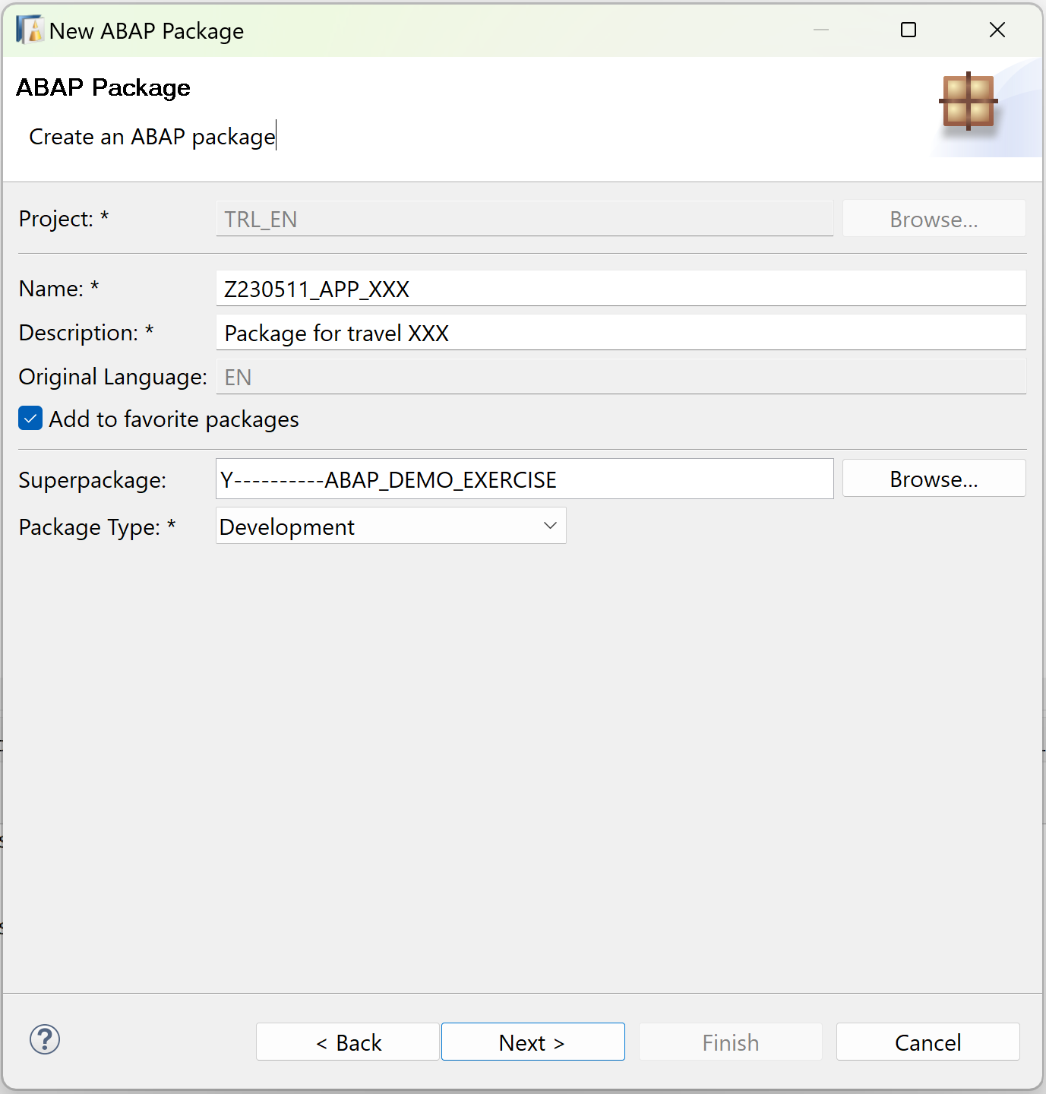

Click Next >.

1. Select Create new request and enter a request description.

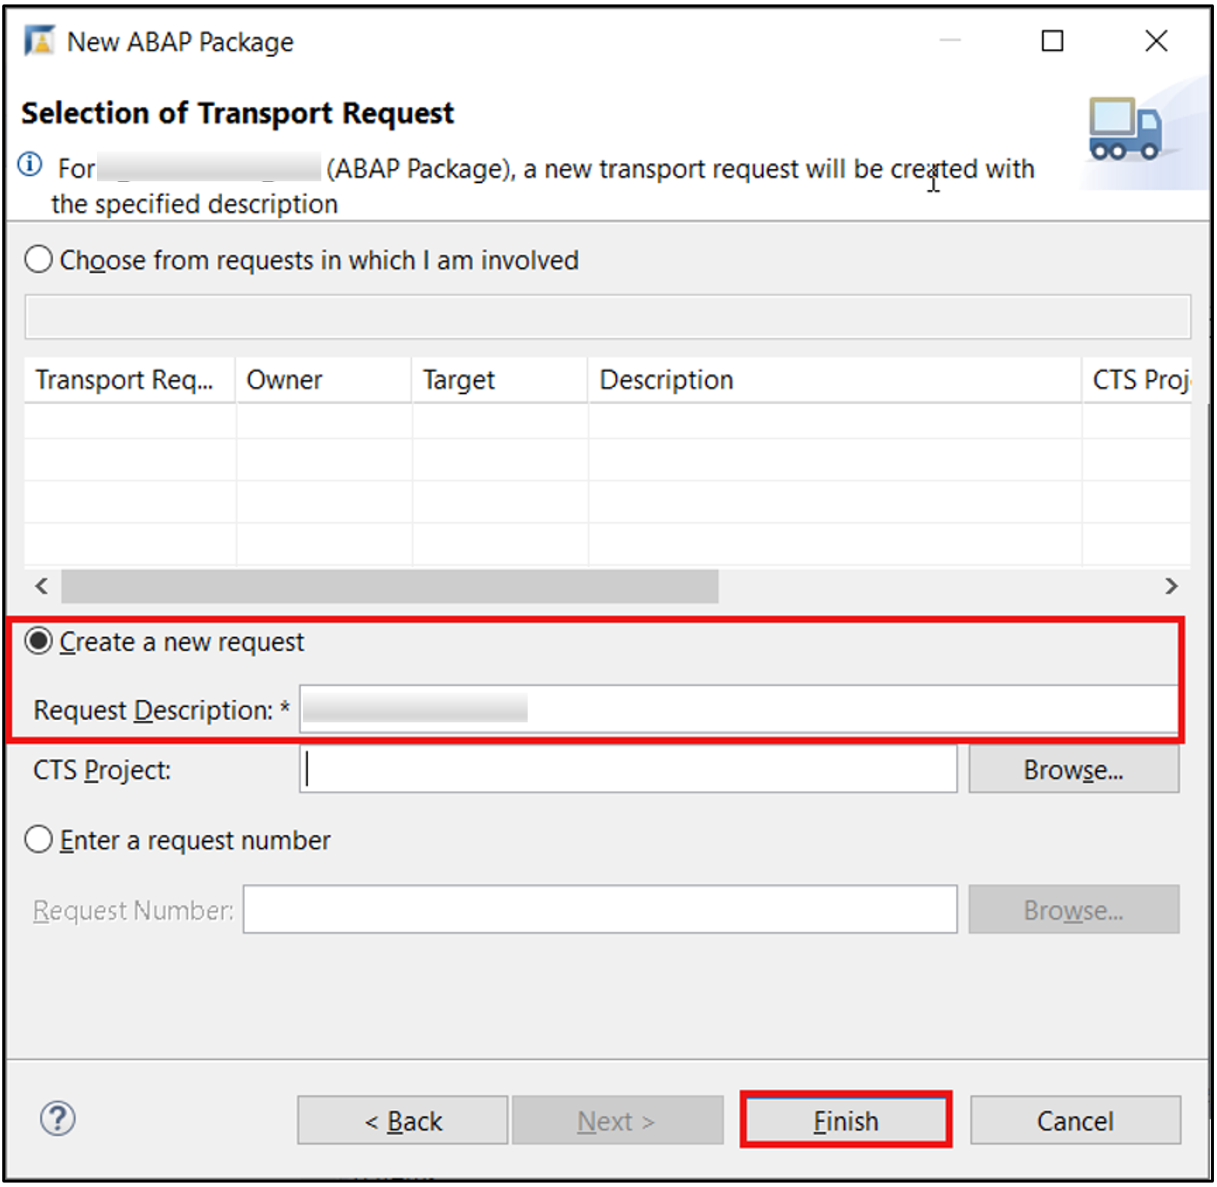

Click Finish.

1. Now your package is added to favorites objects. 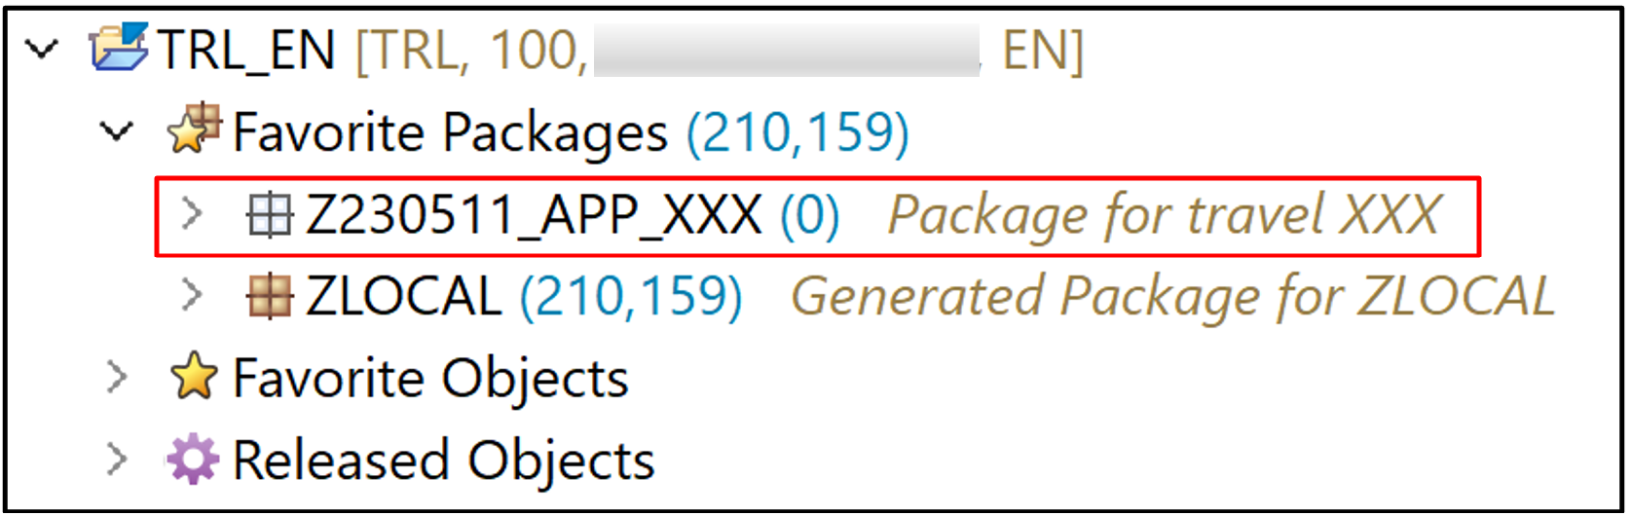

**Step 2 Create database table**

1. Right-click on your package Z230511_APP_XXX, select New > Other ABAP Repository Object.

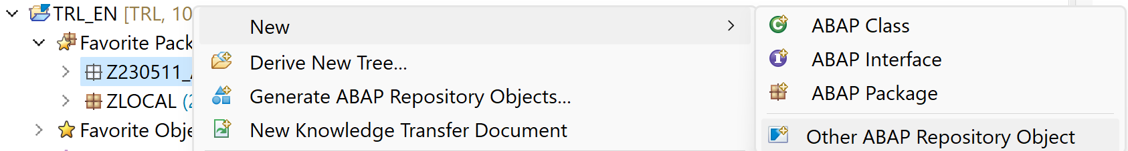

1. Search for database table, select it and click Next >.

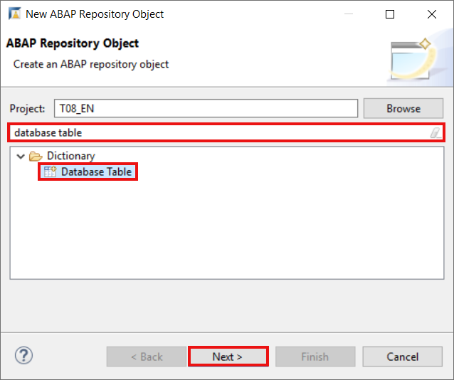

1. Create a new database table:
   * Name: ZTAB_230511_XXX
   * Description: Database table for travel data XXX

Use your number instead of XXX.

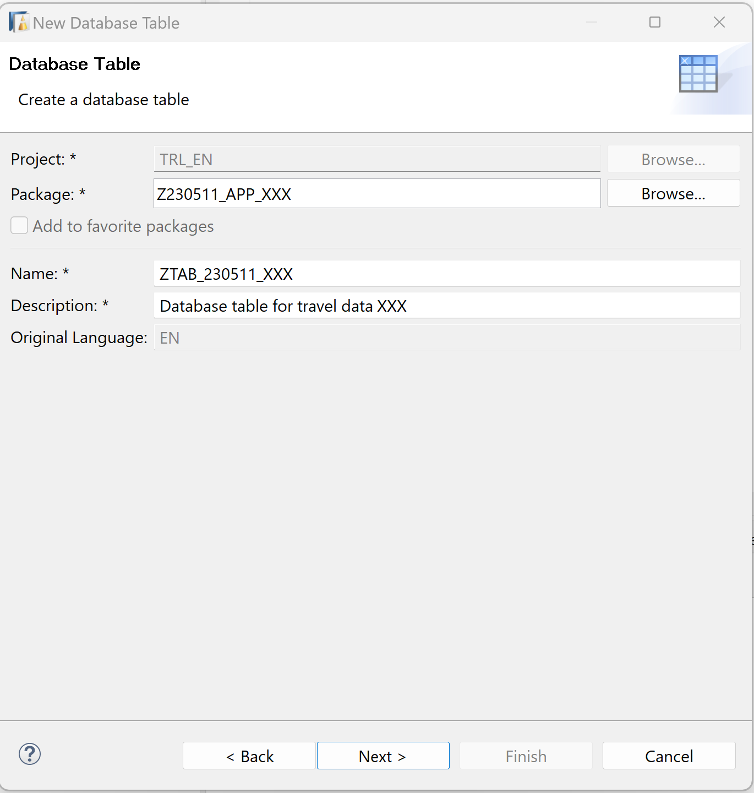

Click Next >.

1. Click Finish to create your transport request.

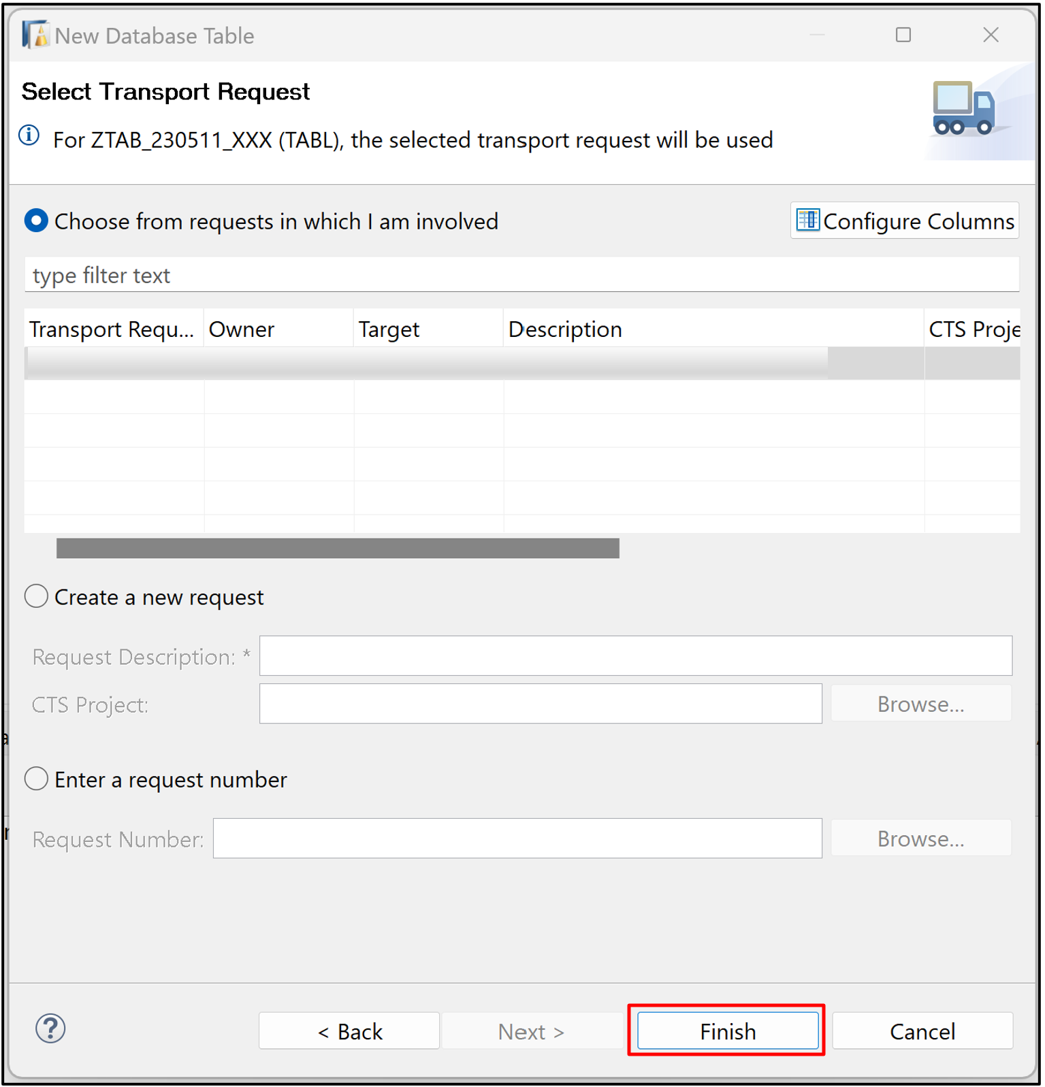

1. Replace your code with following:

Use your number instead of XXX.

ABAP

Copy

@EndUserText.label : 'Database table for travel data XXX'

@AbapCatalog.enhancementCategory : #NOT_EXTENSIBLE

@AbapCatalog.tableCategory : #TRANSPARENT

@AbapCatalog.deliveryClass : #A

@AbapCatalog.dataMaintenance : #RESTRICTED

define table ztab_230511_xxx {

key client : abap.clnt not null;

key mykey : sysuuid_x16 not null;

travel_id : /dmo/travel_id;

agency_id : /dmo/agency_id;

customer_id : /dmo/customer_id;

begin_date : /dmo/begin_date;

end_date : /dmo/end_date;

@Semantics.amount.currencyCode : 'ztab_230511_xxx.currency_code'

booking_fee : /dmo/booking_fee;

@Semantics.amount.currencyCode : 'ztab_230511_xxx.currency_code'

total_price : /dmo/total_price;

currency_code : /dmo/currency_code;

description : /dmo/description;

overall_status : /dmo/overall_status;

created_by : syuname;

created_at : timestampl;

last_changed_by : syuname;

last_changed_at : timestampl;

}

1. Save and activate.

**Step 3 Create ABAP class**

1. Right-click on your package Z230511_APP_XXX, select New > ABAP Class.



1. Create a new ABAP class:
   * Name: ZCL_230511_GENERATE_DATA_XXX
   * Description: Class for generating travel data

Use your number instead of XXX.

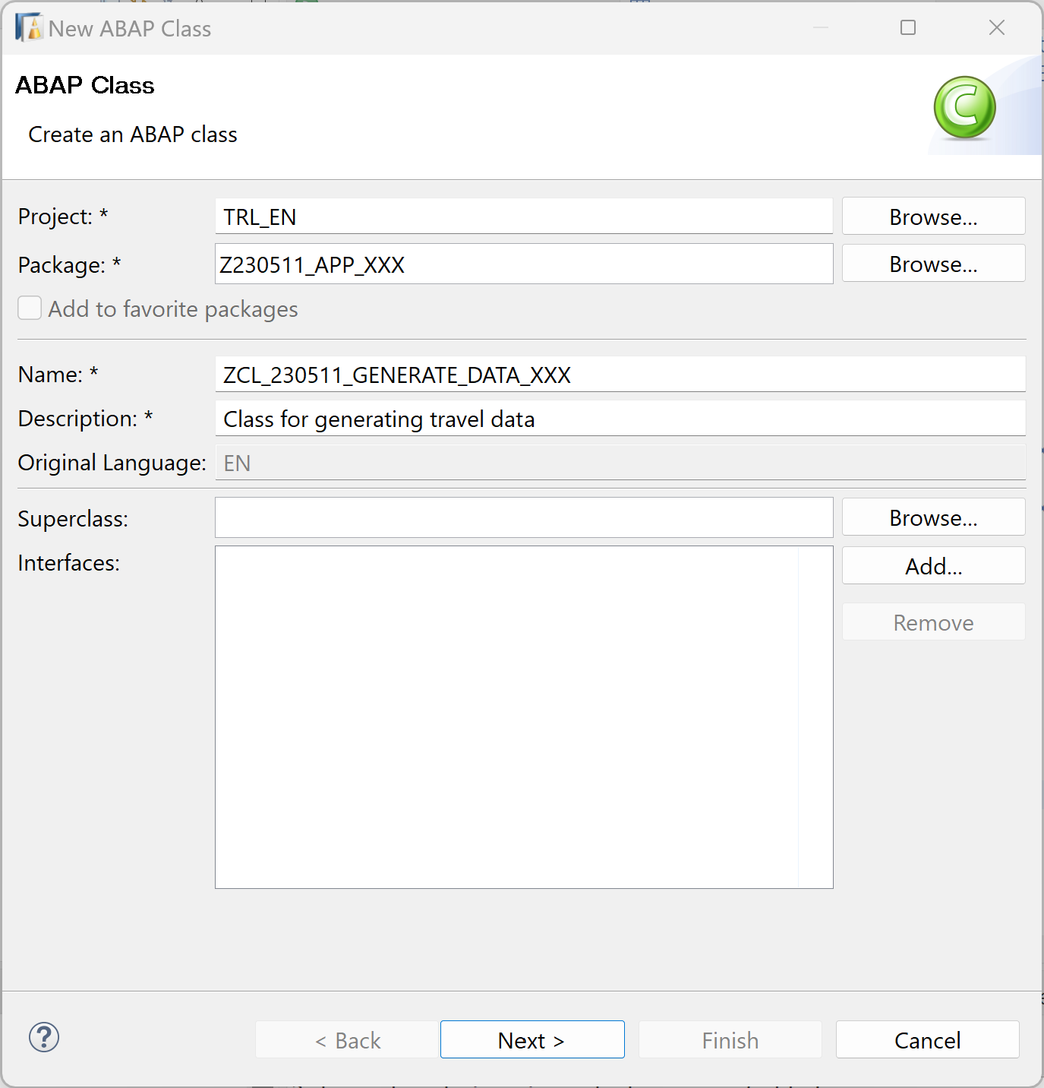

Click Next >.

1. Click Finish to create your transport request.

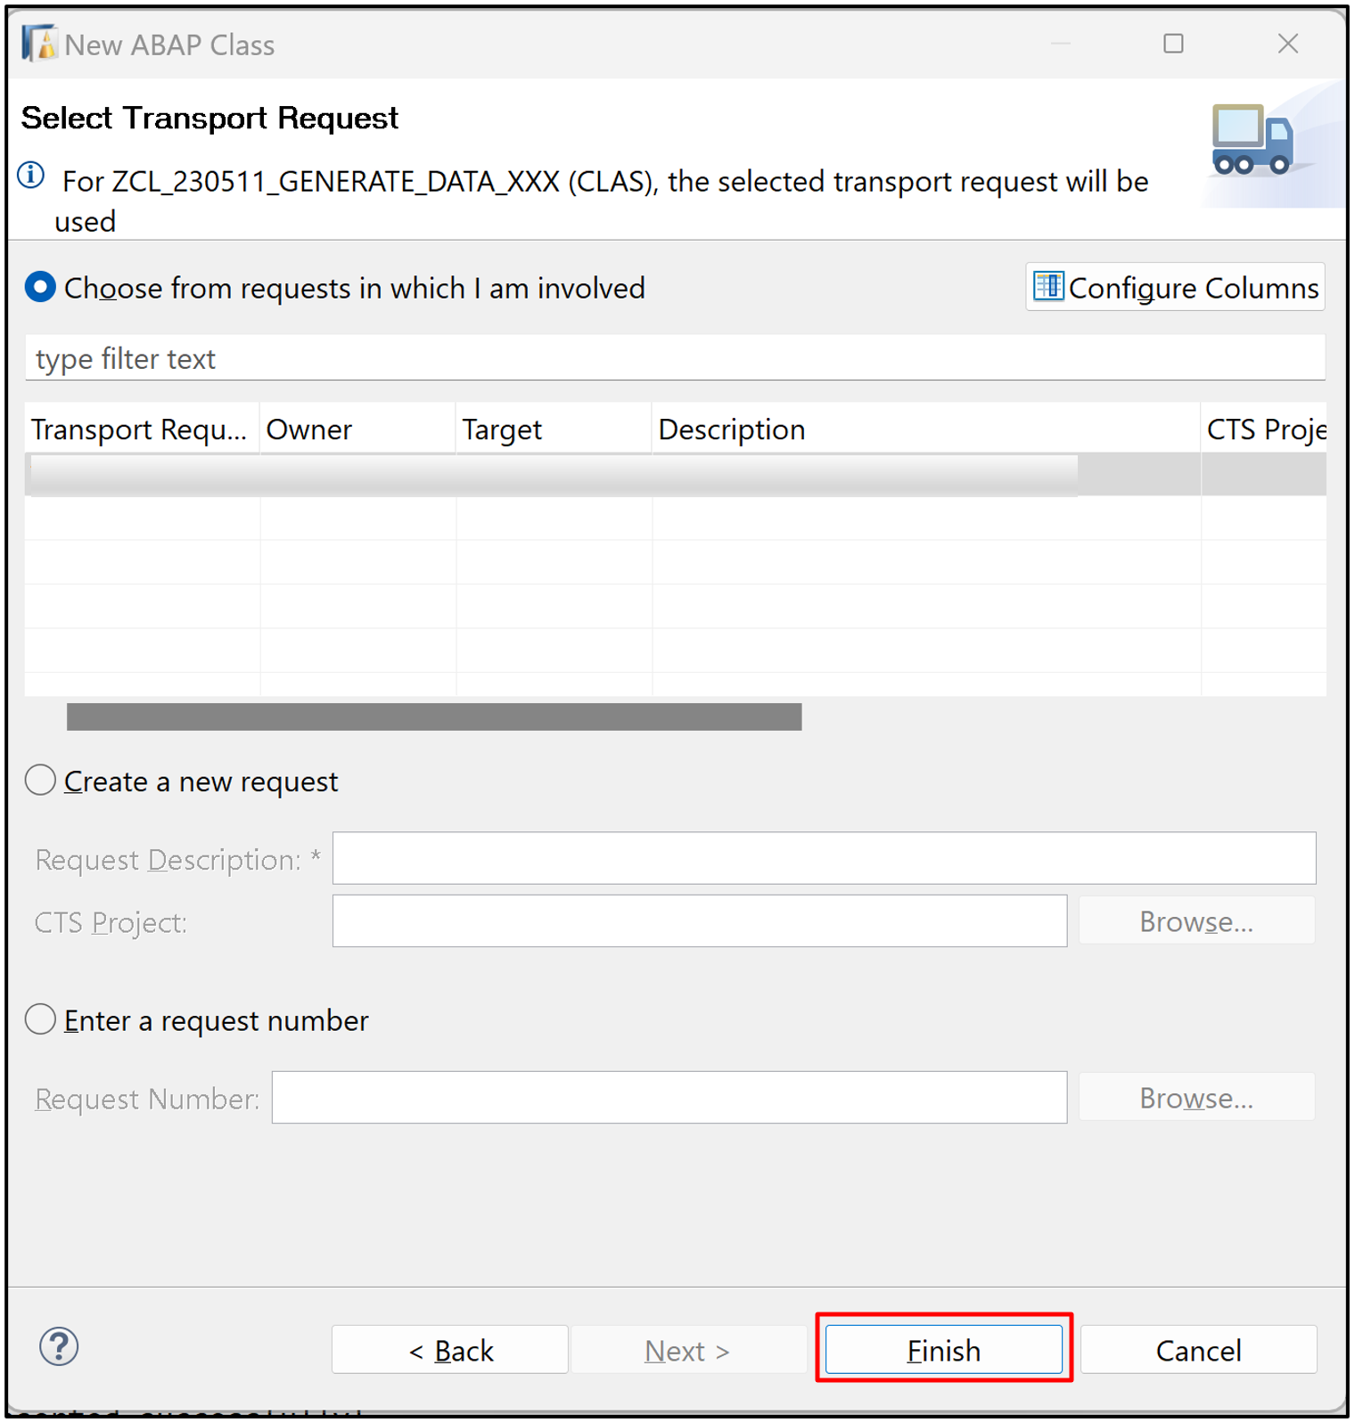

1. Replace your code with following:

Use your number instead of XXX.

ABAP

Copy

CLASS zcl_230511_generate_data_xxx DEFINITION

PUBLIC

FINAL

CREATE PUBLIC .

PUBLIC SECTION.

INTERFACES if_oo_adt_classrun.

PROTECTED SECTION.

PRIVATE SECTION.

ENDCLASS.

CLASS zcl_230511_generate_data_xxx IMPLEMENTATION.

METHOD if_oo_adt_classrun~main.

DATA itab TYPE TABLE OF ztab_230511_xxx.

* fill internal travel table (itab)

itab = VALUE #(

( mykey = '02D5290E594C1EDA93815057FD946624' travel_id = '00000022' agency_id = '070001' customer_id = '000077' begin_date = '20190624' end_date = '20190628' booking_fee = '60.00' total_price = '750.00' currency_code = 'USD'

description = 'mv' overall_status = 'A' created_by = 'MUSTERMANN' created_at = '20190612133945.5960060' last_changed_by = 'MUSTERFRAU' last_changed_at = '20190702105400.3647680' )

( mykey = '02D5290E594C1EDA93815C50CD7AE62A' travel_id = '00000106' agency_id = '070005' customer_id = '000005' begin_date = '20190613' end_date = '20190716' booking_fee = '17.00' total_price = '650.00' currency_code = 'AFN'

description = 'Enter your comments here' overall_status = 'A' created_by = 'MUSTERMANN' created_at = '20190613111129.2391370' last_changed_by = 'MUSTERMANN' last_changed_at = '20190711140753.1472620' )

( mykey = '02D5290E594C1EDA93858EED2DA2EB0B' travel_id = '00000103' agency_id = '070010' customer_id = '000011' begin_date = '20190610' end_date = '20190714' booking_fee = '17.00' total_price = '800.00' currency_code = 'AFN'

description = 'Enter your comments here' overall_status = 'X' created_by = 'MUSTERFRAU' created_at = '20190613105654.4296640' last_changed_by = 'MUSTERFRAU' last_changed_at = '20190613111041.2251330' )

( mykey = '02D5290E594C1EDA93858EED2DA2EB24' travel_id = '00000107' agency_id = '070020' customer_id = '000311' begin_date = '20200210' end_date = '20200314' booking_fee = '22.00' total_price = '913.00' currency_code = 'JPY'

description = 'Travel for Kioto' overall_status = 'X' created_by = sy-uname created_at = '20200211105654.4296640' last_changed_by = 'MUSTERFRAU' last_changed_at = '20210613111041.2251330' )

).

* delete existing entries in the database table

DELETE FROM ztab_230511_xxx.

* insert the new table entries

INSERT ztab_230511_xxx FROM TABLE @itab.

* output the result as a console message

out->write( |{ sy-dbcnt } travel entries inserted successfully!| ).

ENDMETHOD.

ENDCLASS.

1. Save, activate and click F9 to run your ABAP class.

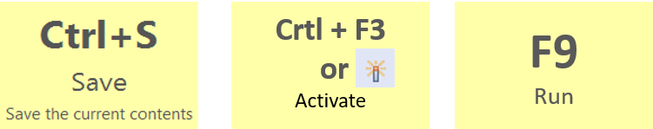

1. Check your result. Therefore open your database table ZTAB_230511_XXX and press F8 to see your data. Now the dictionary tables are filled with data.

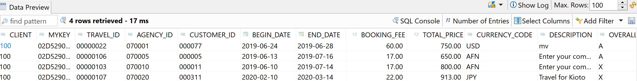

**Step 4 Create CDS view**

1. Right-click on your package Z230511_APP_XXX, select New > Other ABAP Repository Object.



1. Search for data definition, select it and click Next >.

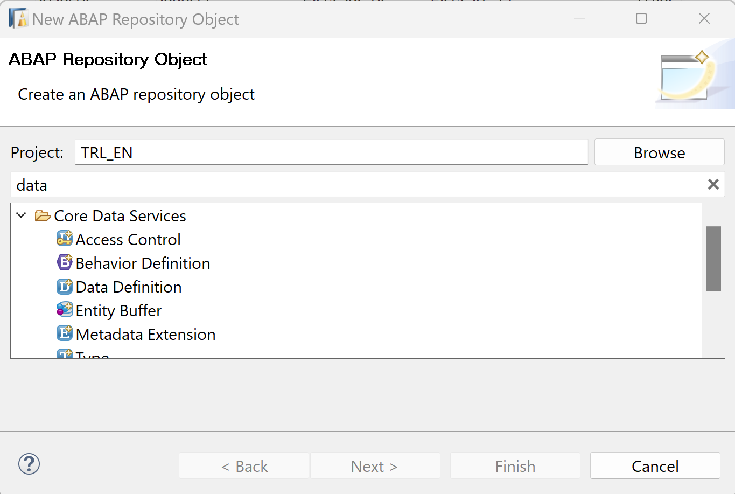

1. Create a new data definition object:
   * Name: ZCDS_230511_XXX
   * Description: CDS for travel data XXX

Use your number instead of XXX.

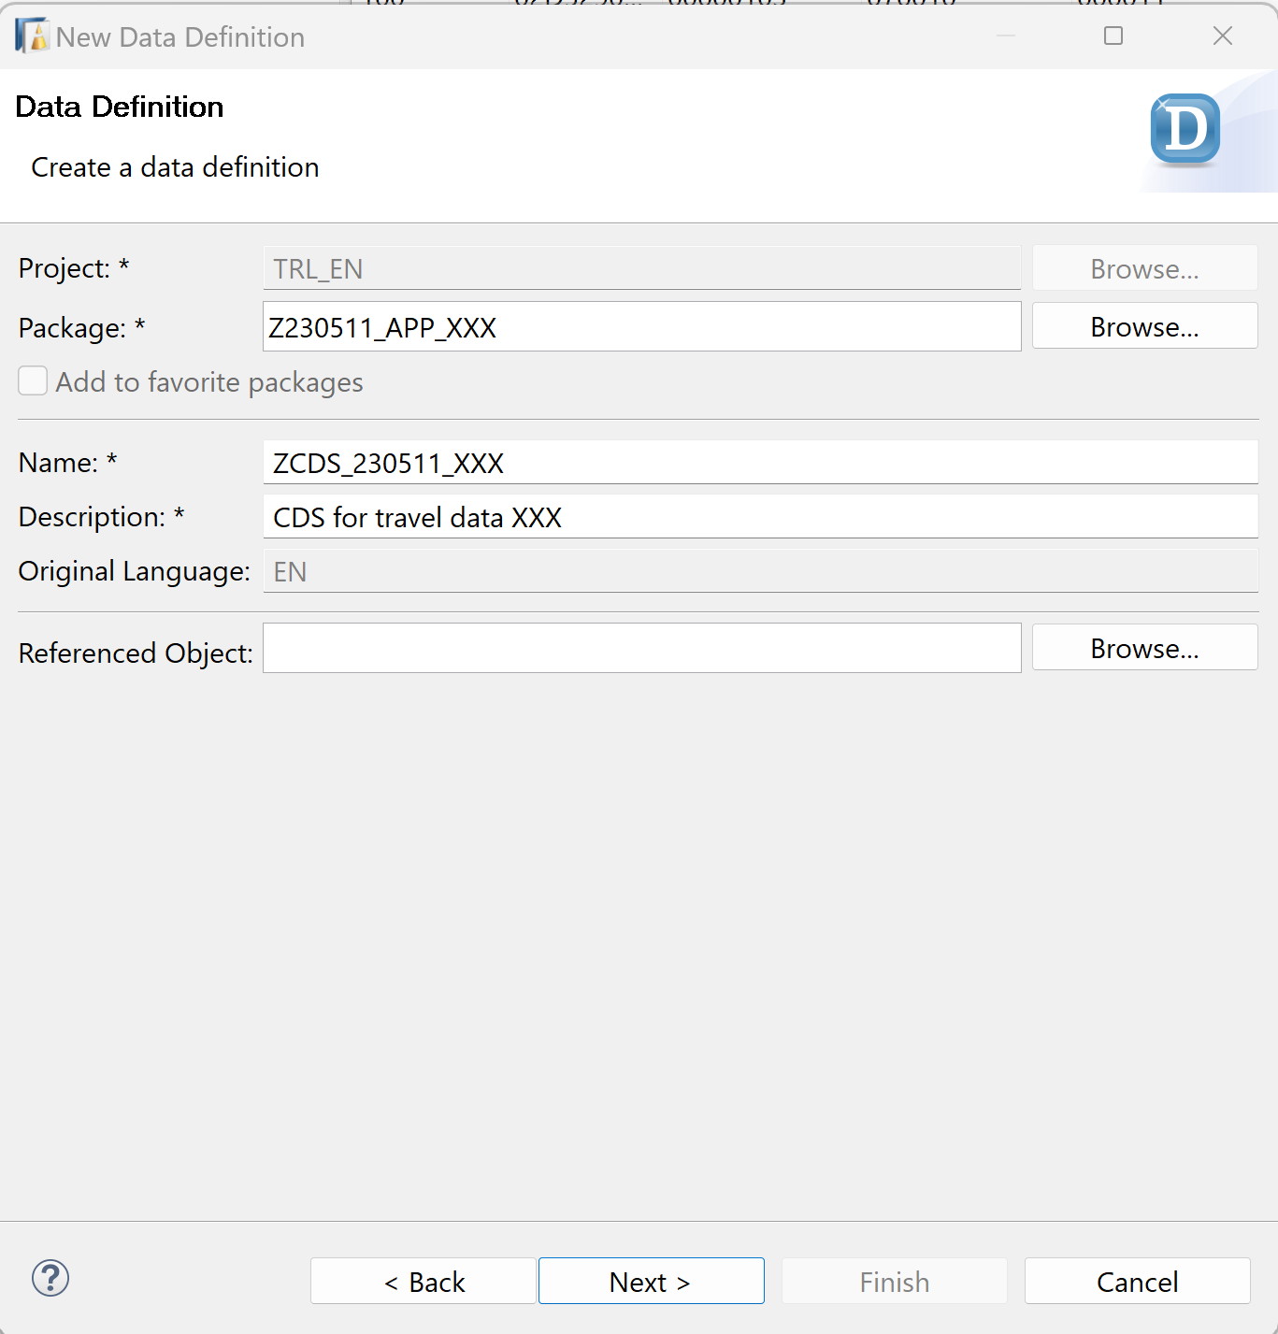

Click Next >.

1. Click Finish to create your transport request.

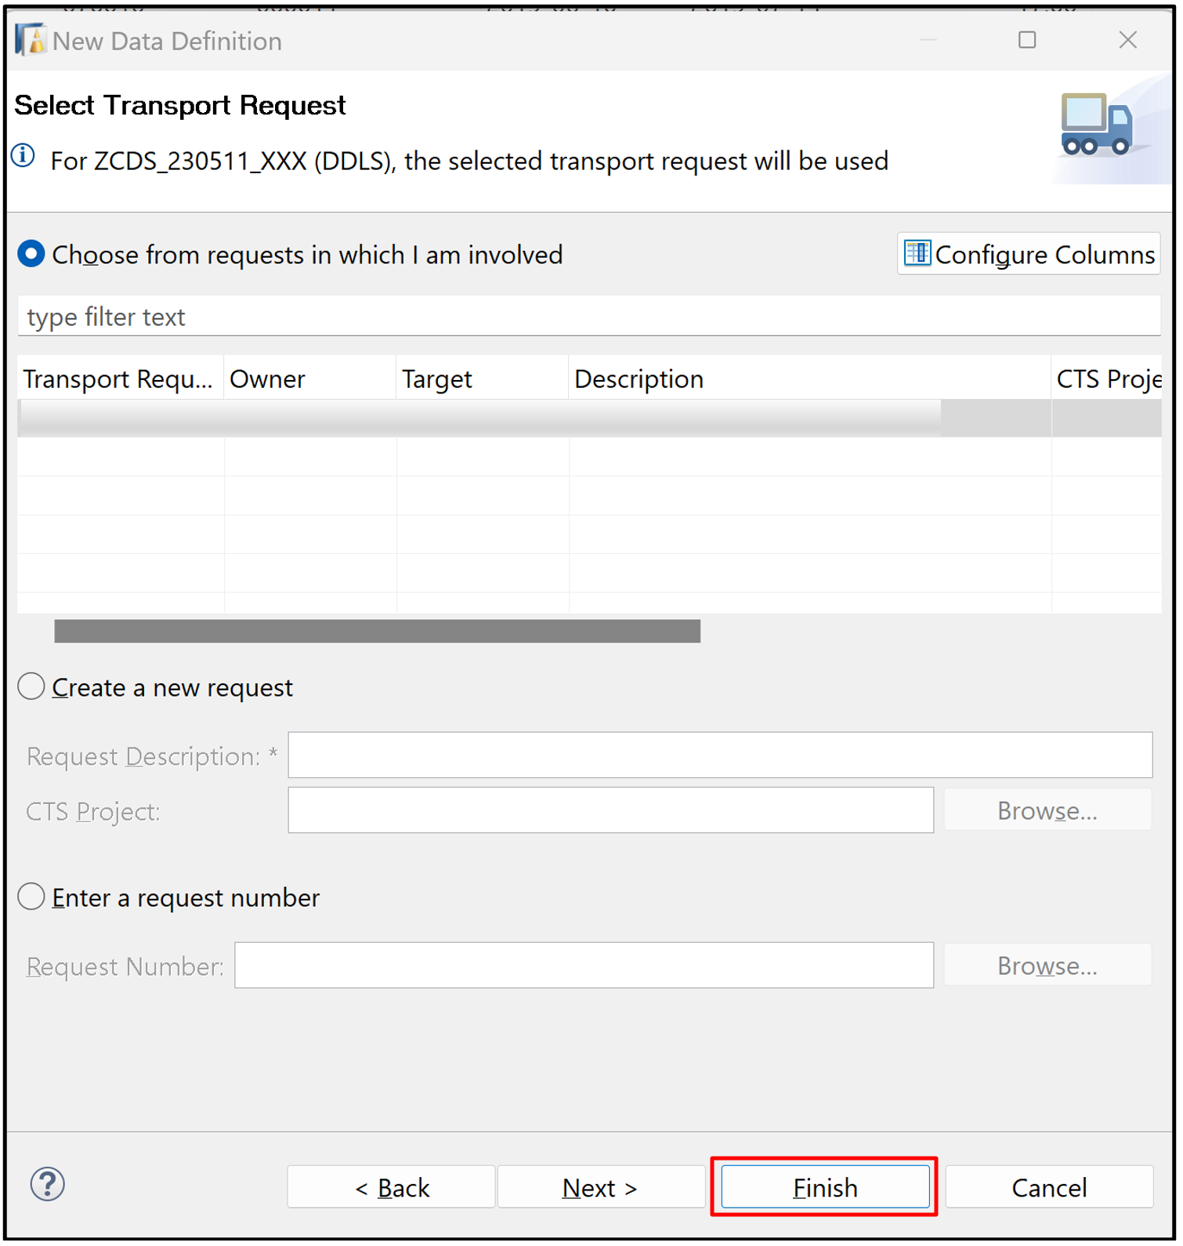

1. Replace your code with following:

Use your number instead of XXX.

ABAP

Copy

@AbapCatalog.sqlViewName: 'ZV_230511_XXX'

@AbapCatalog.compiler.compareFilter: true

@AccessControl.authorizationCheck: #NOT_REQUIRED

@AbapCatalog.viewEnhancementCategory: [#NONE]

@EndUserText.label: 'CDS for travel data XXX'

@Metadata.allowExtensions: true

define view ZCDS_230511_XXX

as select from ztab_230511_xxx

{

key mykey,

travel_id,

agency_id,

customer_id,

begin_date,

end_date,

@Semantics.amount.currencyCode : 'currency_code'

booking_fee,

@Semantics.amount.currencyCode : 'currency_code'

total_price,

@Semantics.currencyCode: true

currency_code,

description,

overall_status,

created_by,

created_at,

last_changed_by,

last_changed_at

}

1. Save and activate.

**Step 5 Create Metadata Extension**

1. Navigate through your package  Z230511_APP_XXX, Right-click on your CDS ZCDS_230511_XXX, select New Metadata Extension.

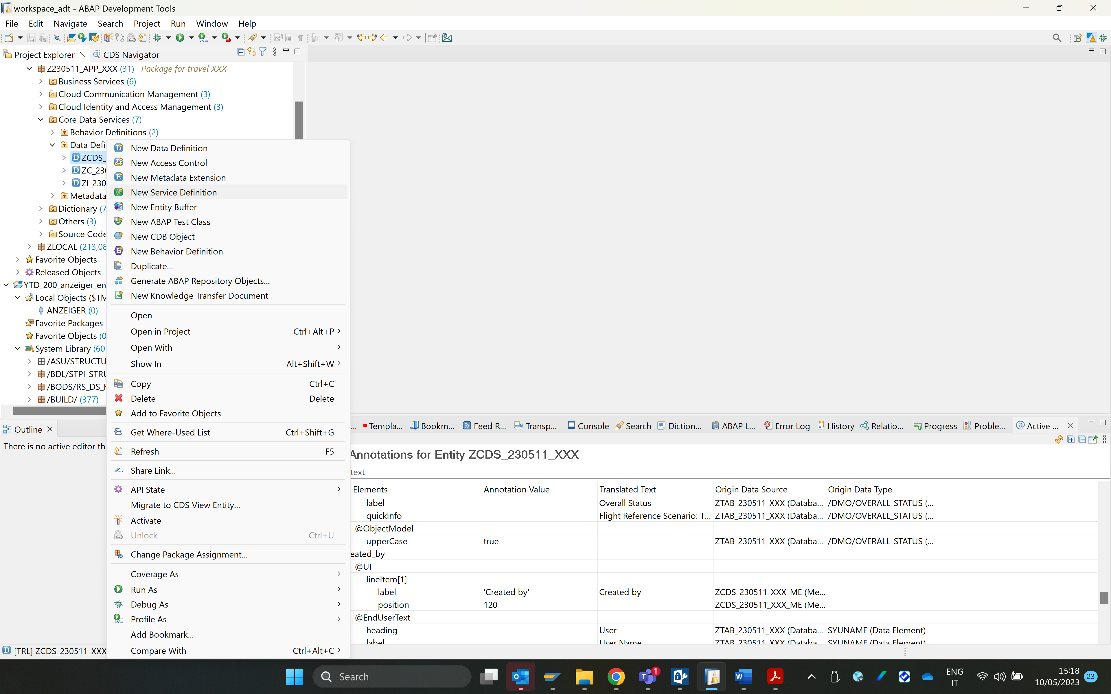

1. Create a new metadata extension object:
   * Name: ZME_230511_XXX
   * Description: Metadata Extension for travel data XXX

Use your number instead of XXX.

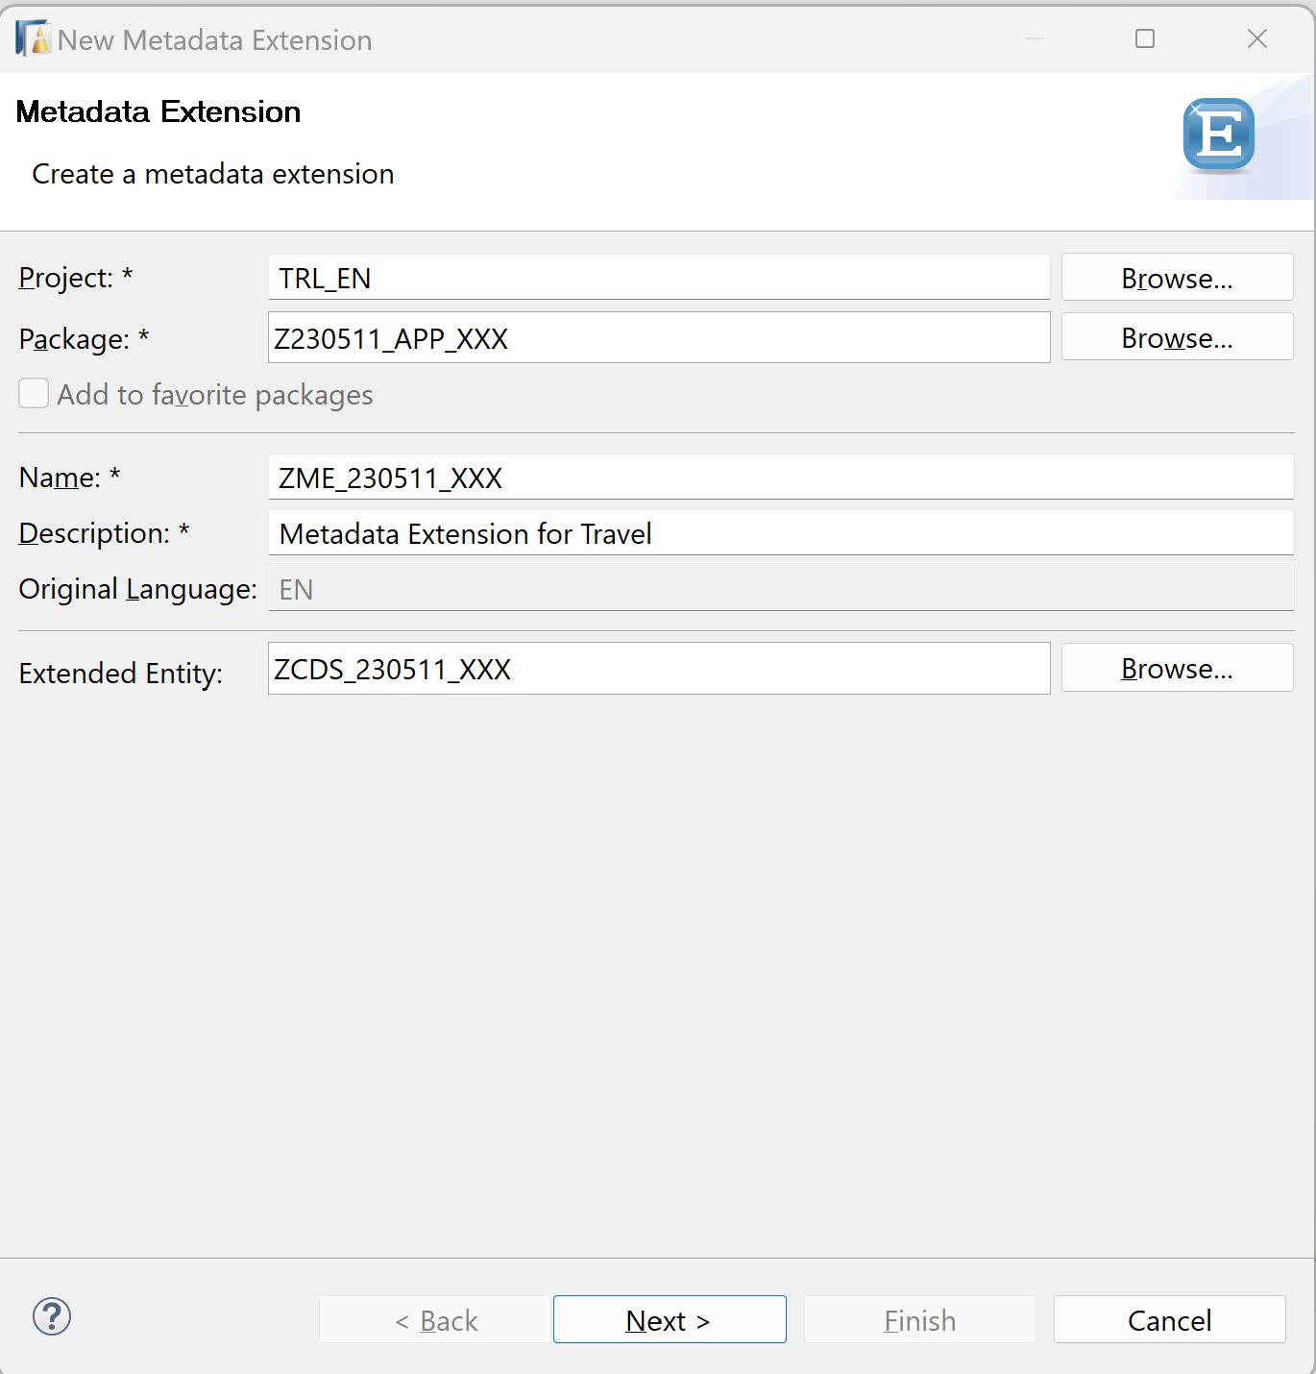Click Next >.

1. Click Finish to create your transport request. 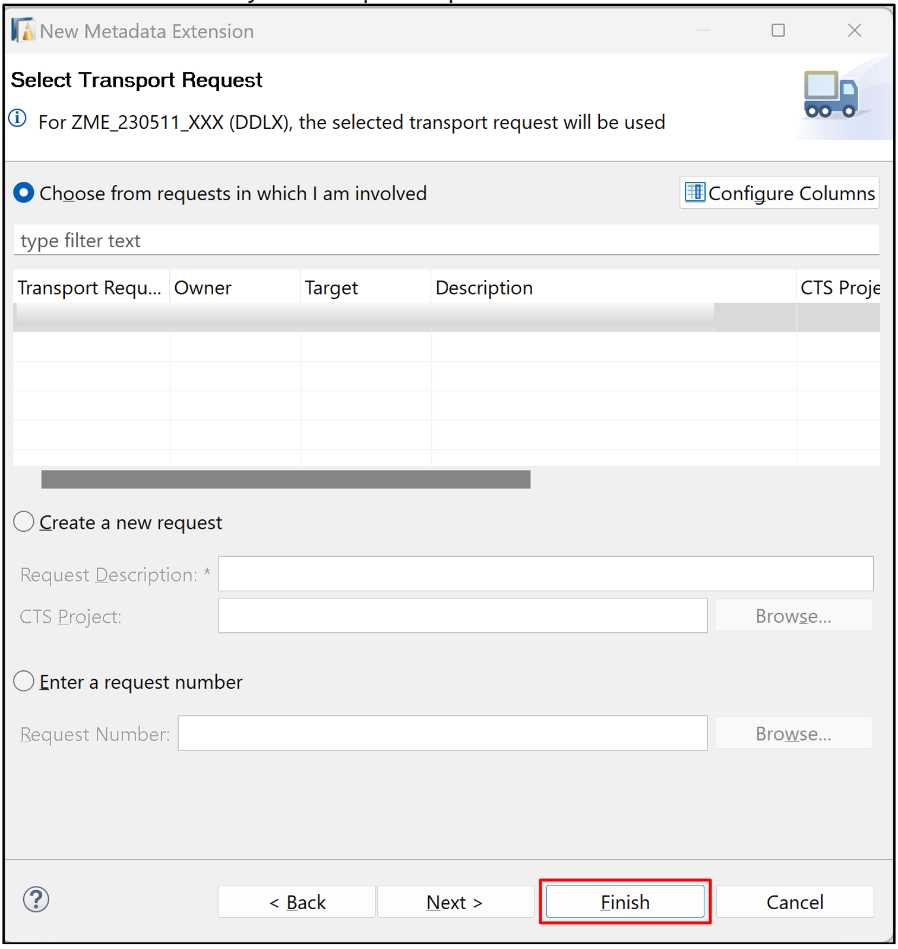
2. Replace your code with following:

Use your number instead of XXX.

ABAP

Copy

@Metadata.layer: #CUSTOMER

@UI: {

headerInfo: {

typeName: 'Travel XXX',

typeNamePlural: 'Travels XXX'

}

}

@Search.searchable: true

annotate view ZCDS_230511_XXX

with

{

@UI: { lineItem: [ { position: 10 ,

label: 'Unique Key' } ],

hidden: true }

mykey;

@UI.lineItem: [ { position: 20 ,

label: 'Travel ID' } ]

@UI.selectionField: [{position: 10 }]

travel_id;

@UI.lineItem: [ { position: 30 ,

label: 'Agency ID' } ]

agency_id;

@UI.lineItem: [ { position: 40 ,

label: 'Customer ID' } ]

customer_id;

@UI.lineItem: [ { position: 50 ,

label: 'Begin date' } ]

begin_date;

@UI.lineItem: [ { position: 60 ,

label: 'End date' } ]

end_date;

@UI.lineItem: [ { position: 70 ,

label: 'Booking fee' } ]

booking_fee;

@UI.lineItem: [ { position: 80 ,

label: 'Total price' } ]

total_price;

@UI.lineItem: [ { position: 90 ,

label: 'Currency' } ]

currency_code;

@UI.lineItem: [ { position: 100 ,

label: 'Description' } ]

@Search: { defaultSearchElement: true,

fuzzinessThreshold: 0.8,

ranking: #HIGH }

description;

@UI.lineItem: [ { position: 110 ,

label: 'Status' } ]

@UI.selectionField: [{position: 20 }]

overall_status;

@UI.lineItem: [ { position: 120 ,

label: 'Created by' } ]

created_by;

@UI.lineItem: [ { position: 130 ,

label: 'Created at' } ]

created_at;

@UI: { lineItem: [ { position: 140 ,

label: 'Last changed by' } ],

hidden: true }

last_changed_by;

@UI: { lineItem: [ { position: 150 ,

label: 'Last changed by' } ],

hidden: true }

last_changed_at;

}

1. Save and activate.

**Step 6 Create Service Definition**

1. Navigate through your package  Z230511_APP_XXX, Right-click on your CDS ZCDS_230511_XXX, select New Service Definition.

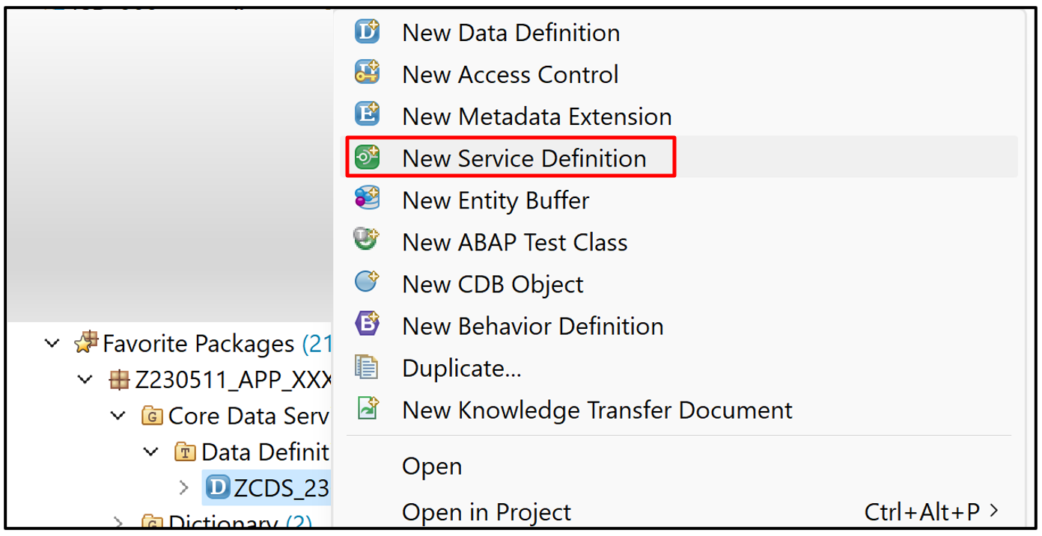

1. Create a new service definition object:
   * Name: ZSD_230511_XXX
   * Description: Service Definition for travel data XXX

Use your number instead of XXX.

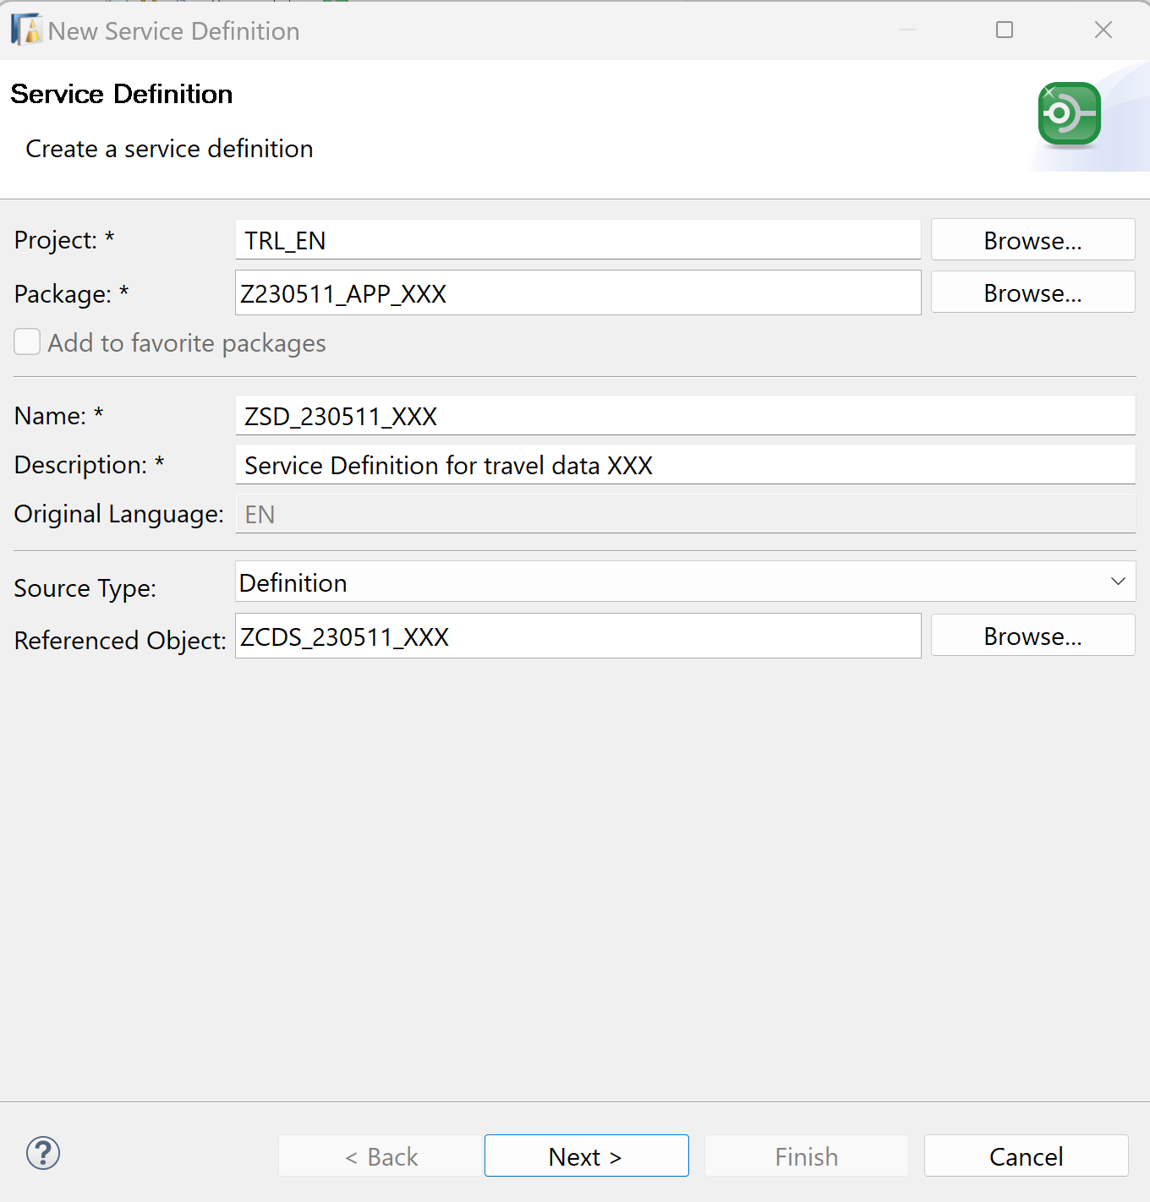Click Next >.

1. Click Finish to create your transport request. 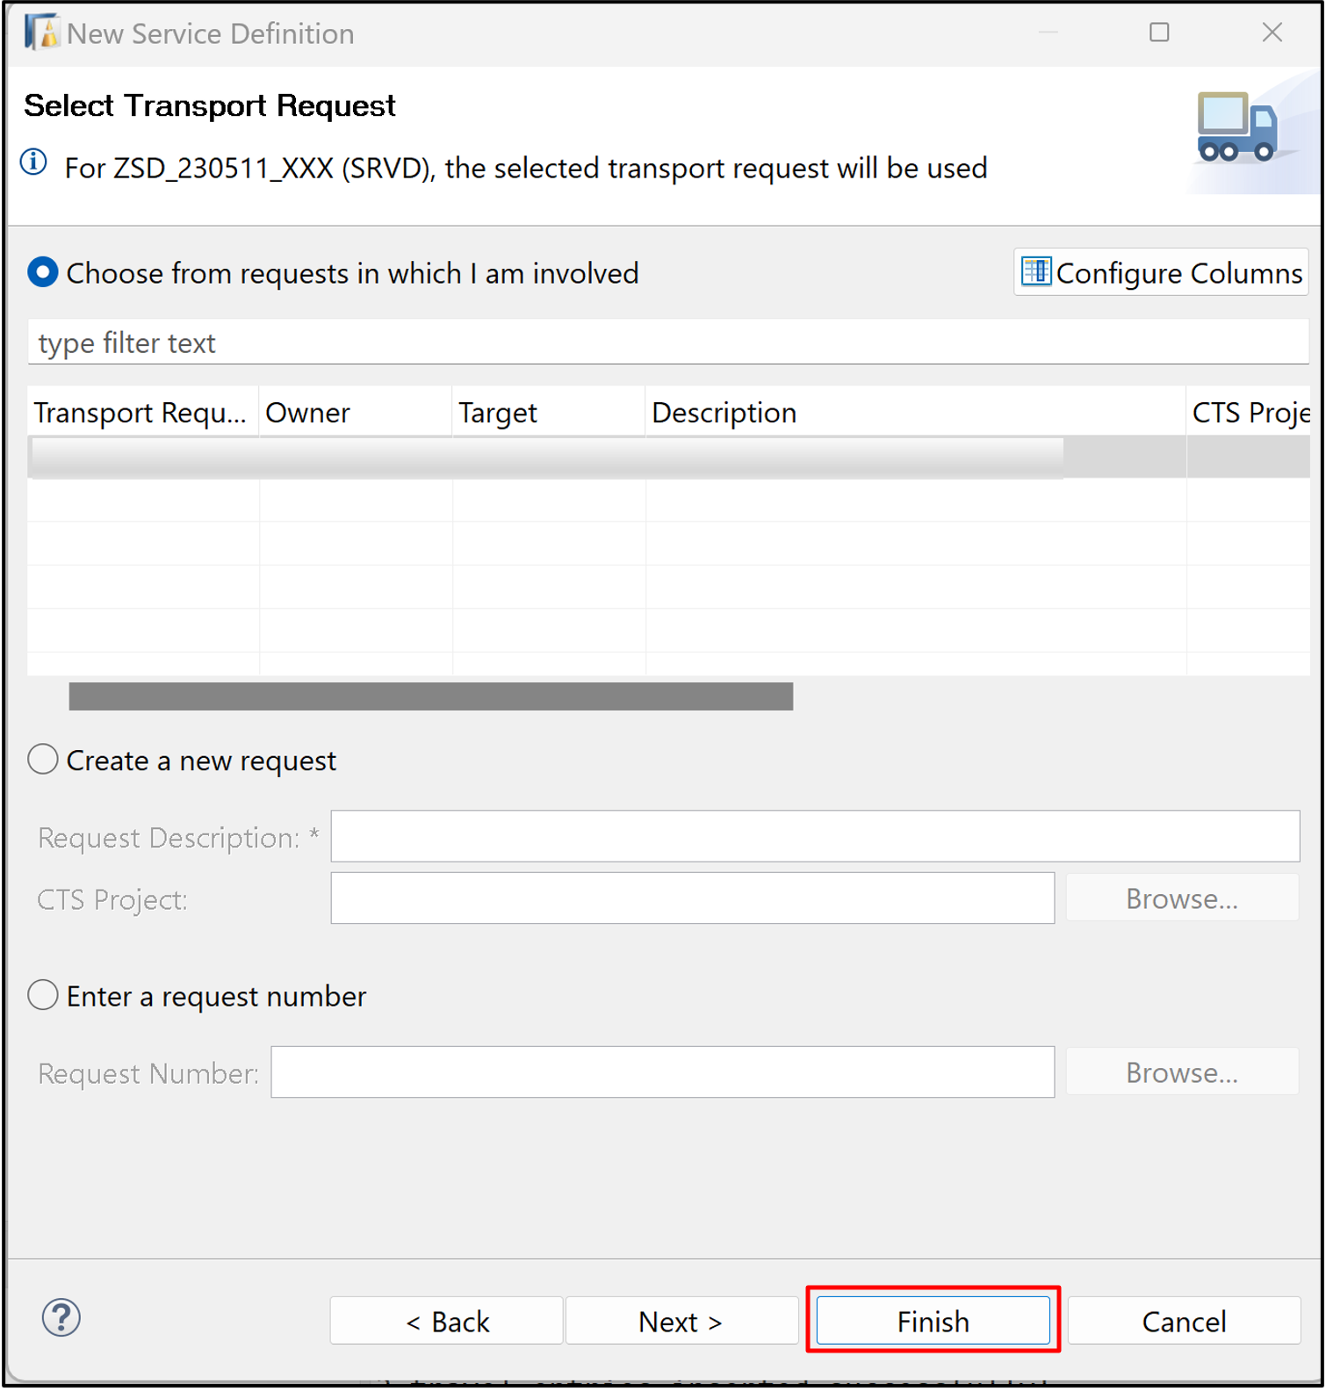
2. Replace your code with following:

Use your number instead of XXX.

ABAP

Copy

@EndUserText.label: 'Service Definition for travel data XXX'

define service ZSD_230511_XXX

{

Expose ZCDS_230511_XXX as Travel;

}

1. Save and activate.

**Step 6 Create Service Binding**

1. Navigate through your package  Z230511_APP_XXX, Right-click on your Service Definition ZSD_230511_XXX, select New Service Binding.

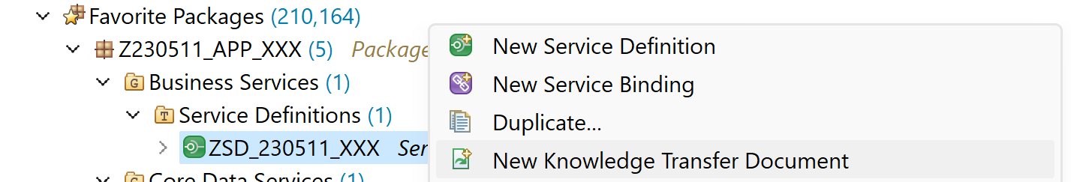

1. Create a new service binding:
   * Name: ZSB_230511_XXX
   * Description: Service Binding for travel data XXX
   * Binding Type: OData V2 – UI

Use your number instead of XXX.

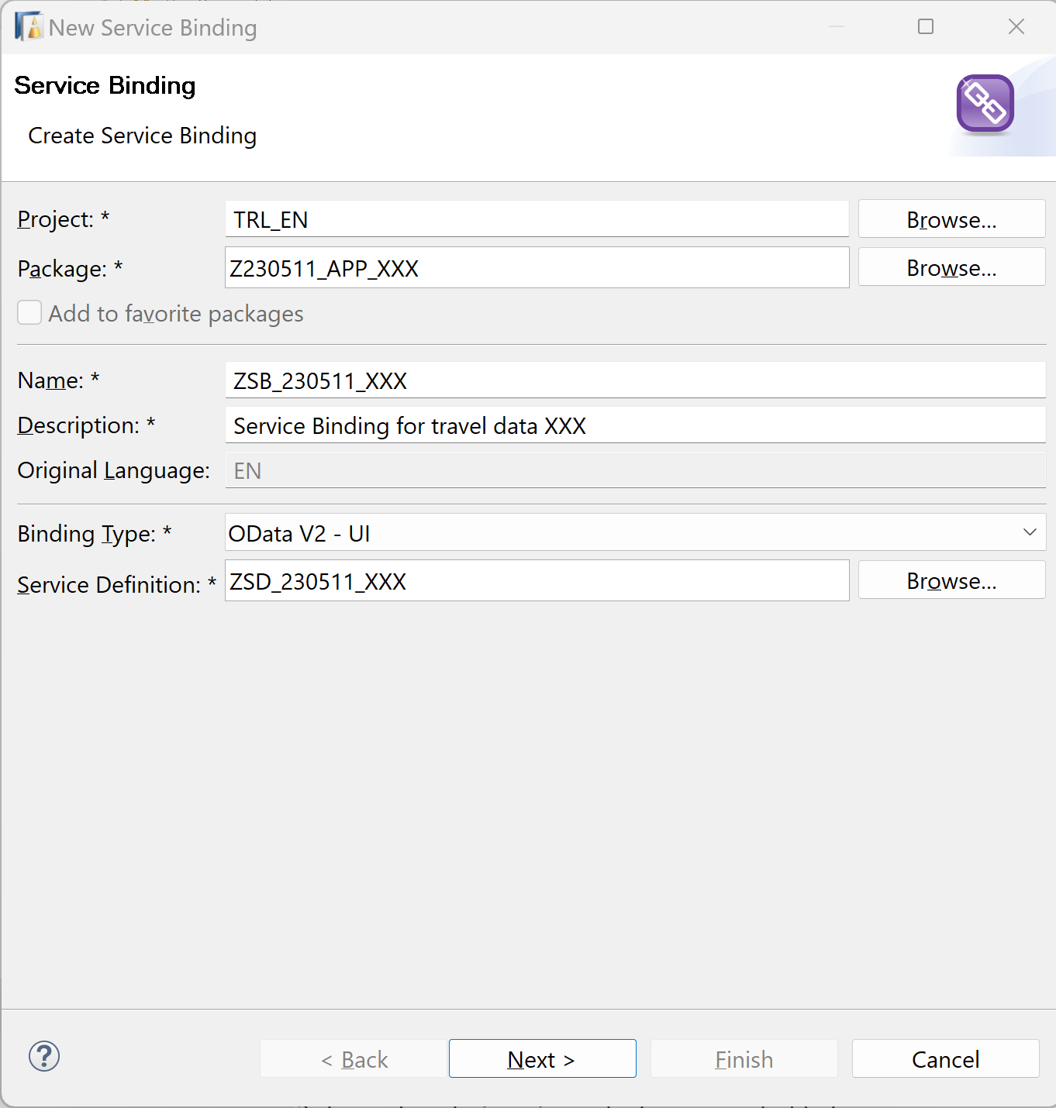Click Next >.

1. Click Finish to create your transport request. 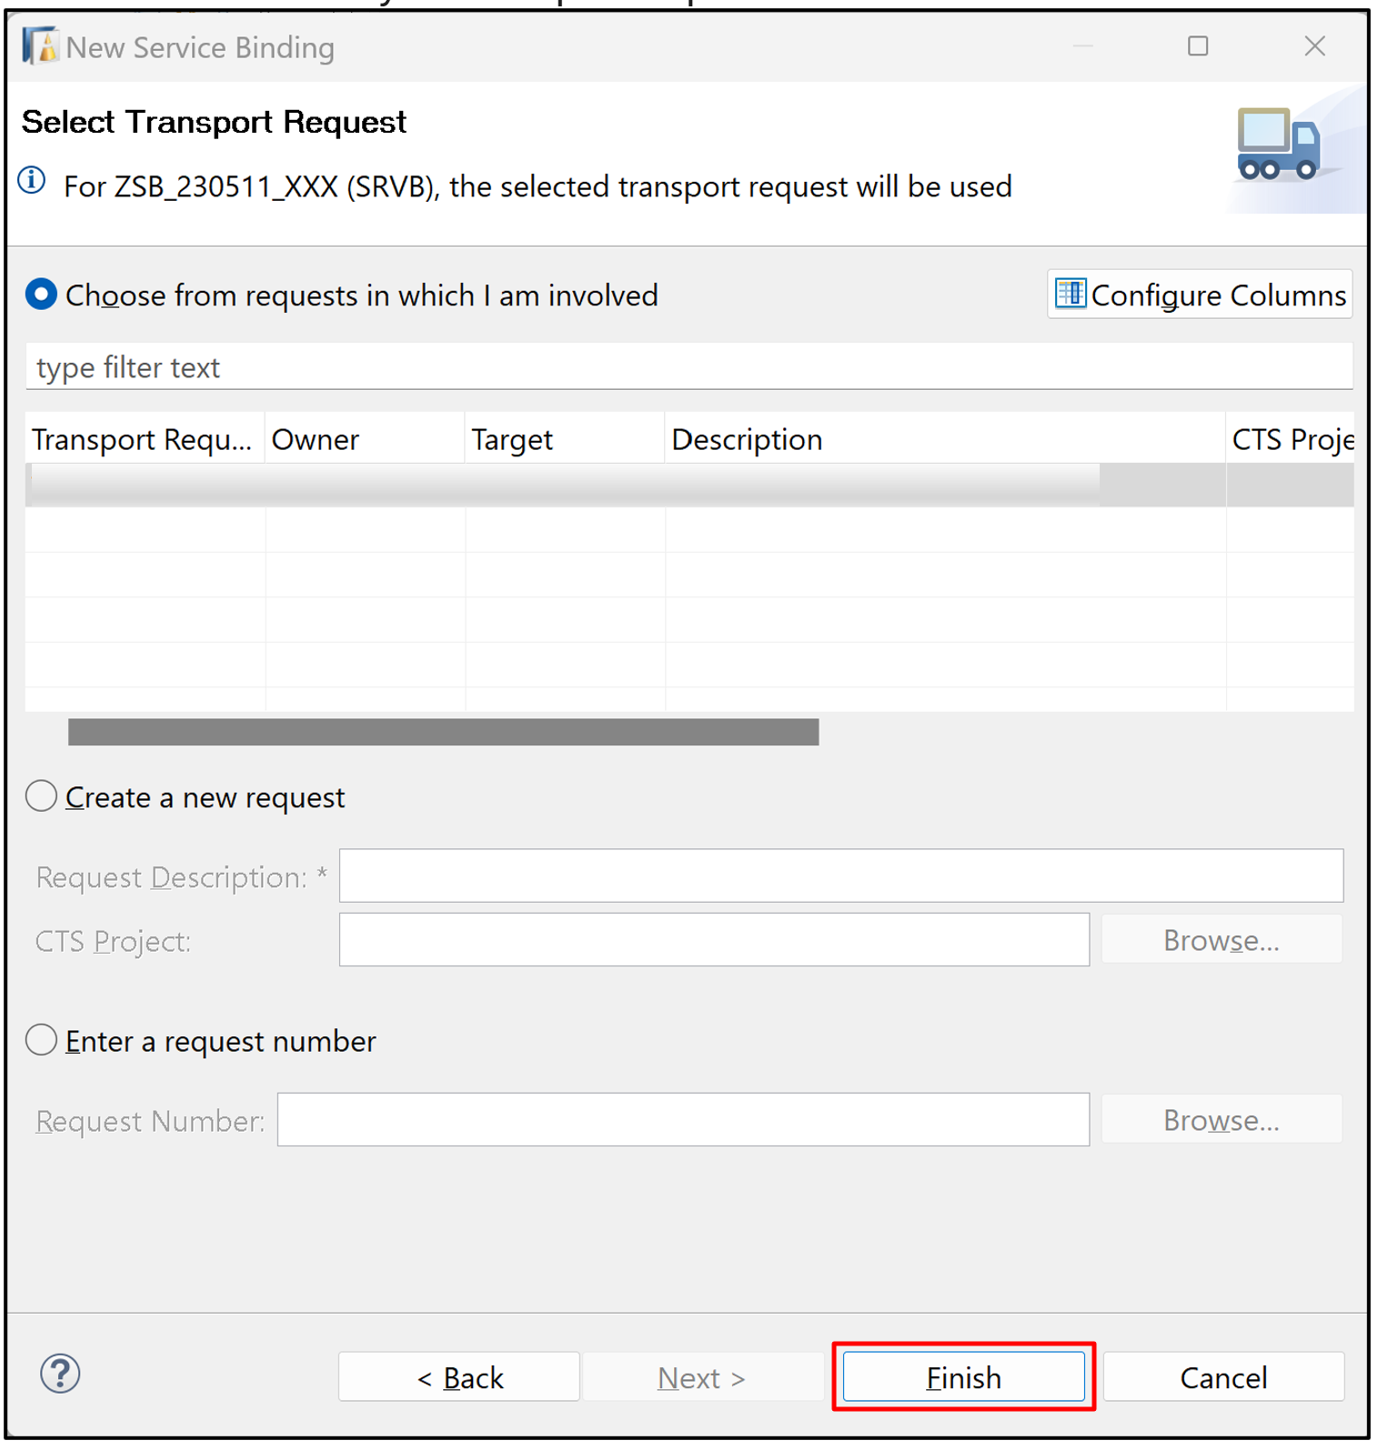
2. Activate the Service Binding:

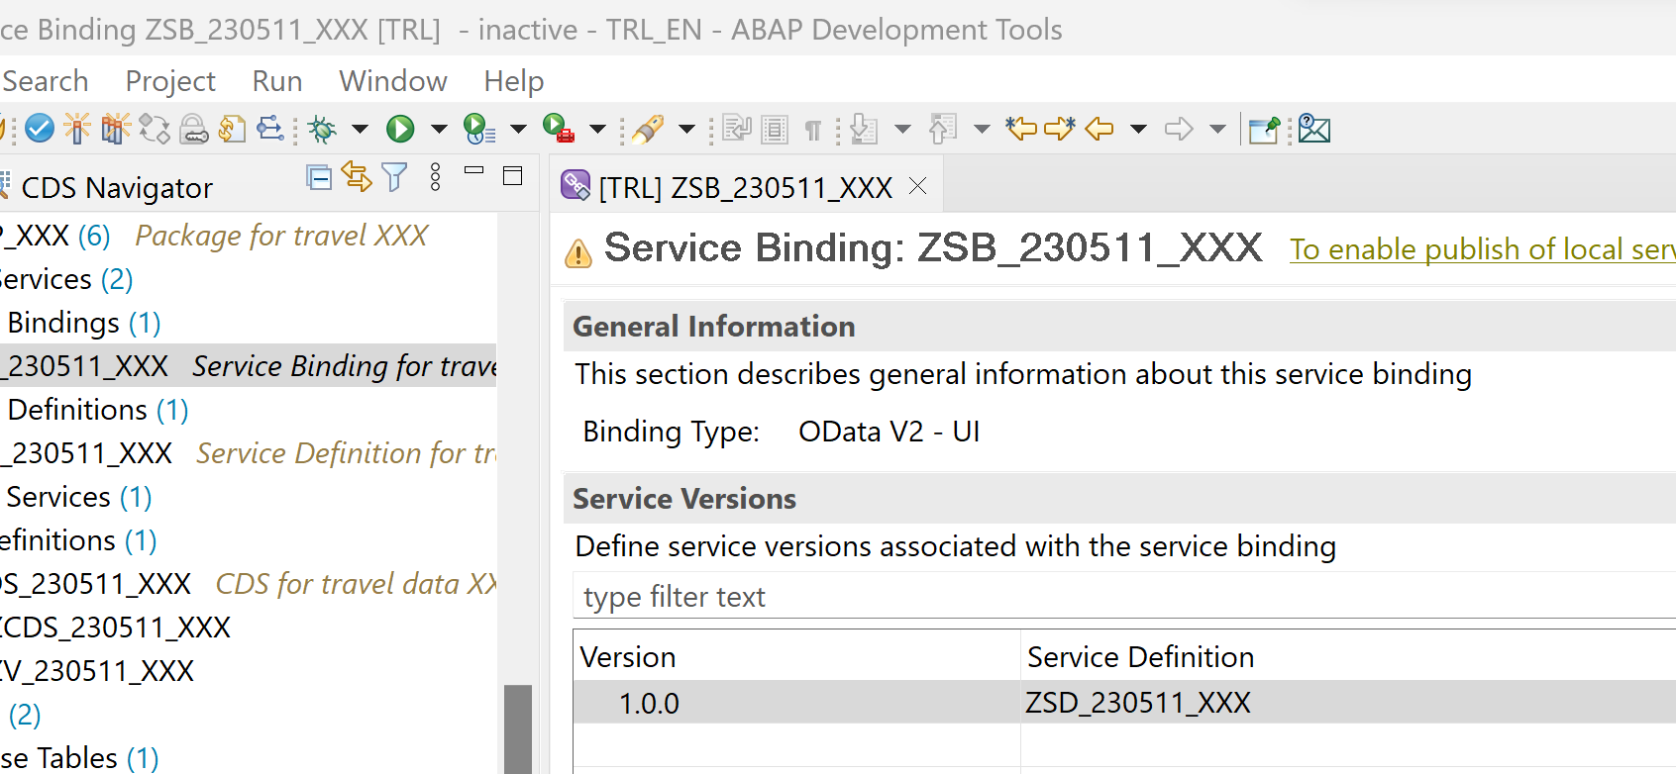

1. Publish the service.

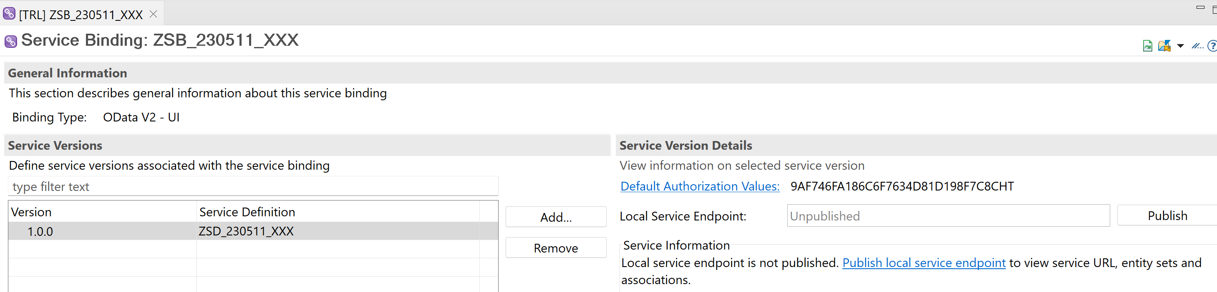

No modify, close or refresh the service binding during the Publish operation.

1. Call the service.

At the end of Publishing operation the service will be ready.

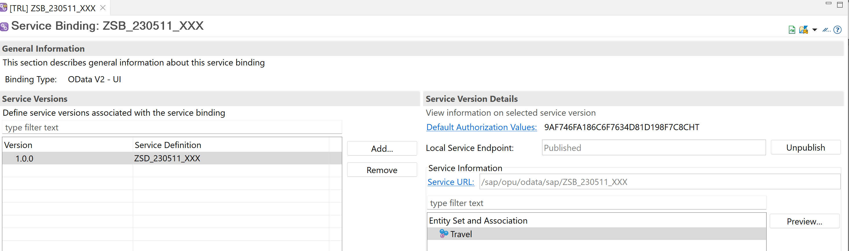

**Exercise 02 Generate a RAP Business Service With the Wizard**

**Step 1 Create database table**

1. Choose your package, then choose **New > Other Repository Object** from the context menu.



1. Choose **Database Table** then **Next**.

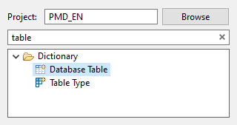

1. Enter the following, then choose **Next**.
   * Name: ZRAP_230511_XXX
   * Description: **Travel Data Generated**

Use your number instead of XXX.

1. Choose the transport request, then choose **Finish**.
2. The table appears in a new editor.
3. Delete the code key client : abap.clnt; and add the following:

Use your number instead of XXX.

ABAP

Copy

key client : abap.clnt not null;

key travel_uuid : sysuuid_x16 not null;

travel_id : /dmo/travel_id not null;

agency_id : /dmo/agency_id;

customer_id : /dmo/customer_id;

begin_date : /dmo/begin_date;

end_date : /dmo/end_date;

@Semantics.amount.currencyCode : 'zrap_230511_XXX.currency_code'

booking_fee : /dmo/booking_fee;

@Semantics.amount.currencyCode : 'zrap_230511_XXX.currency_code'

total_price : /dmo/total_price;

currency_code : /dmo/currency_code;

description : /dmo/description;

overall_status : /dmo/overall_status;

local_created_by : abp_creation_user;

local_created_at : abp_creation_tstmpl;

local_last_changed_by : abp_locinst_lastchange_user;

local_last_changed_at : abp_locinst_lastchange_tstmpl;

last_changed_at : abp_lastchange_tstmpl;

1. Format, save, and activate your table ( Shift+F1, Ctrl+S, Ctrl+F3 ).

**Step 2 Generate objects from table**

1. Select your table and choose **Generate ABAP Repository objects…** from the context menu.

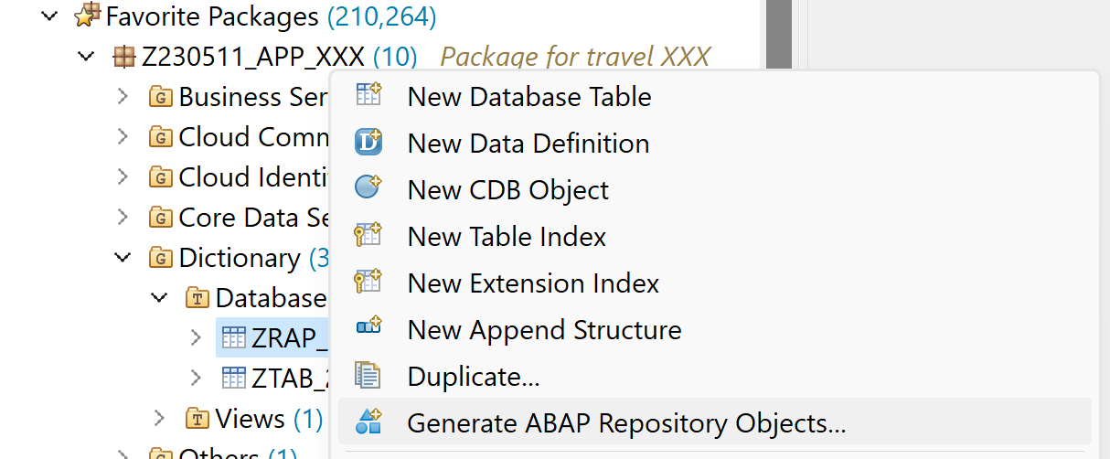

1. Select the following and choose **Next**.
   * Use case: ABAP RESTful Application Programming Model: OData UI Service

Use your number instead of XXX.

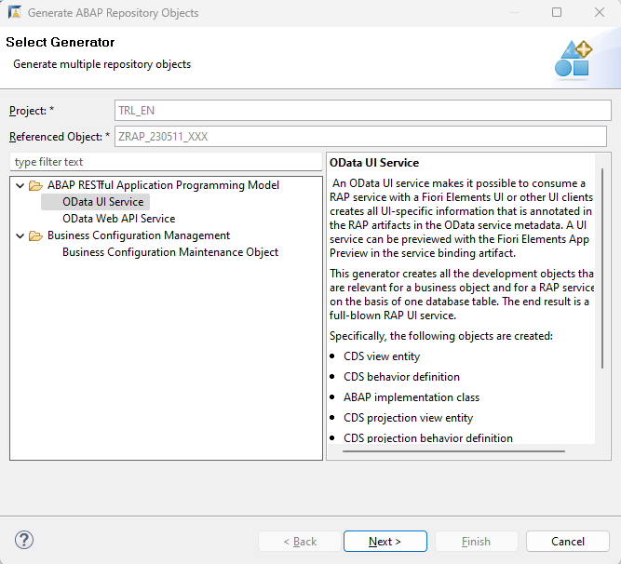

1. Enter the following:
   * Data definition name: ZI_230511_XXX
   * Alias name: Travel

Use your number instead of XXX.

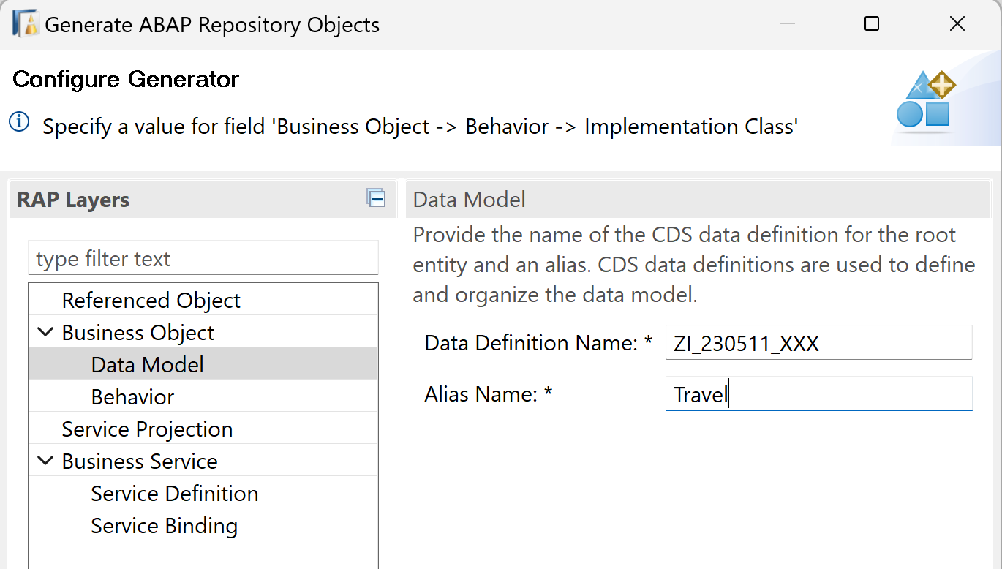

1. Enter the following information for each artifact, then choose **Next**

Use your number instead of XXX.

| **Node** | **Artifact** | **Value** |
| --- | --- | --- |
| Behavior | ABAP implementation class | ZBP_I_230511_XXX |
| Behavior | Draft Table Name: | ZRAP_230511_D_XX |
| Service Projection | CDS projection view entity | ZC_230511_XXX |
| Service Definition | CDS service definition | ZUI_230511_XXX |
| Service Binding | CDS service binding | ZUI_230511_O4_XXX |
| Service Binding | Binding type: | OData V4 - UI |

1. The system displays a list of objects that will be generated. Choose **Next**

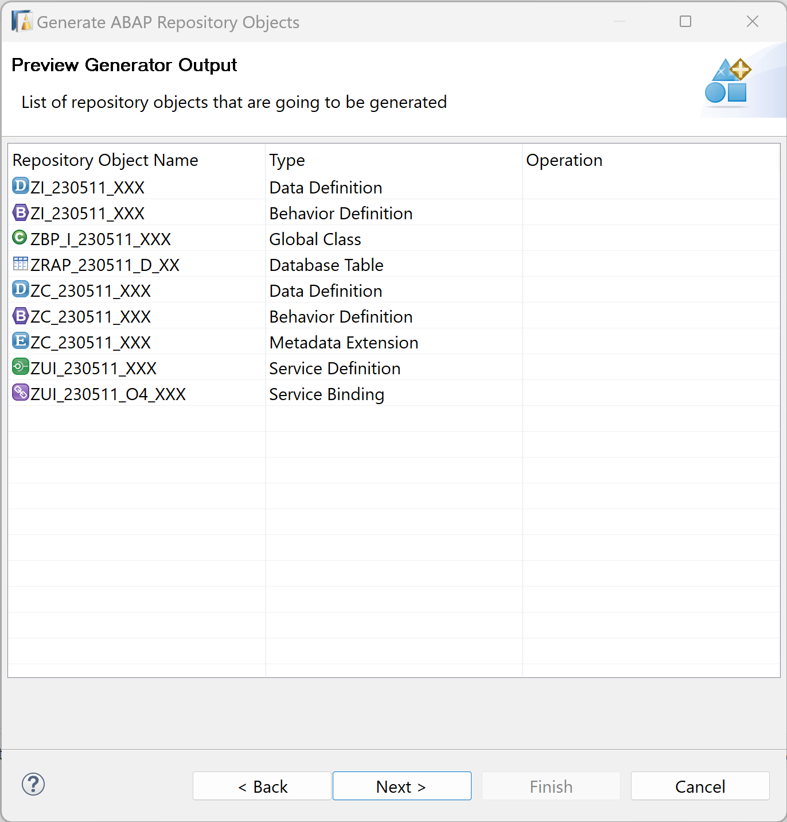

1. Choose the transport request, then choose **Finish**.

**Step 3 Activate and publish your business service**

1. The service binding appears automatically in a new editor.

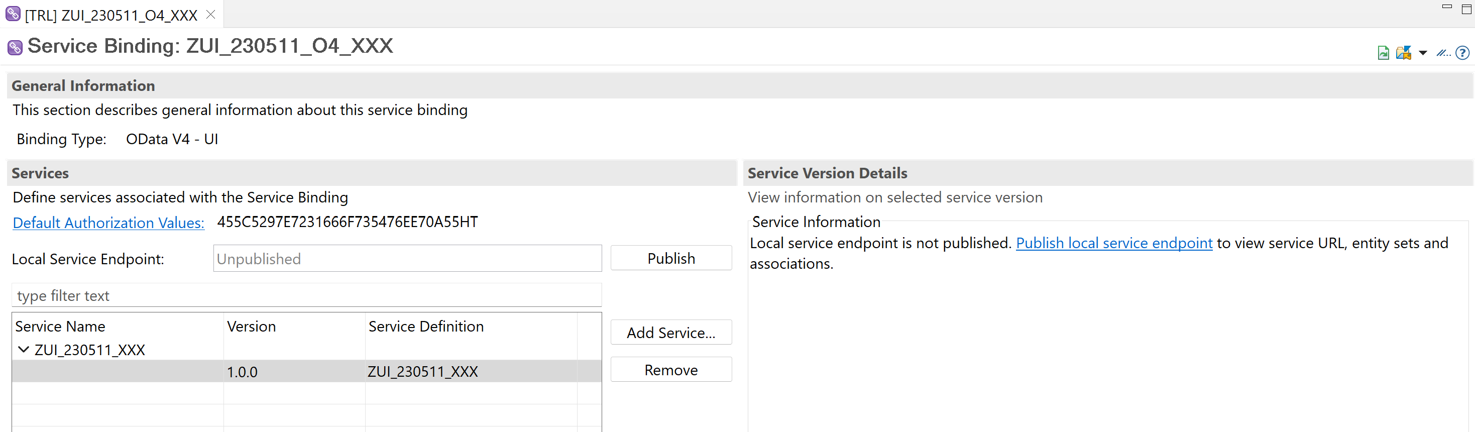

1. Activate the service binding.

step4a-activate

1. Publish the service binding.

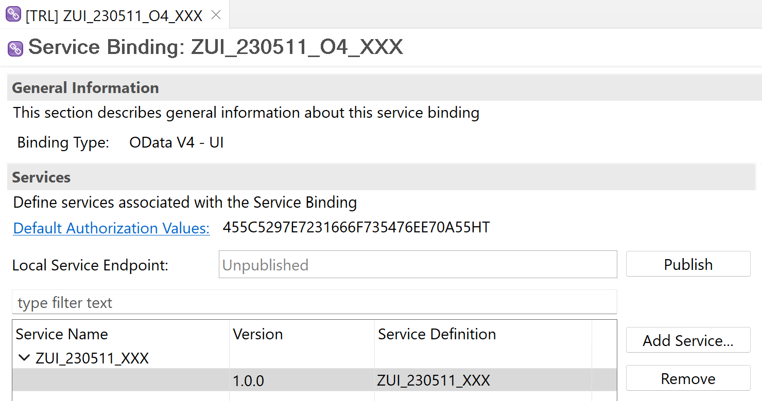

No modify, close or refresh the service binding during the Publish operation.

1. Create a new service binding (OData V2):
   * Name: ZUI_230511_O2_XXX
   * Description: Service binding for travel data V2
   * Binding Type: OData V2 – UI

Use your number instead of XXX.

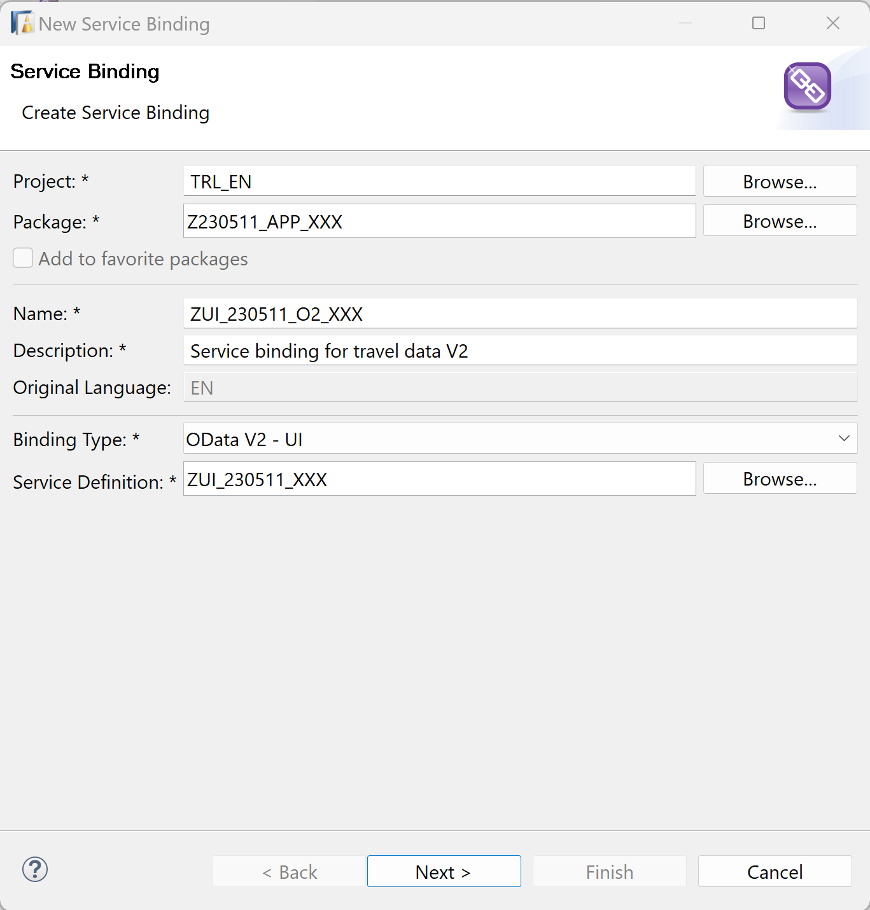Click Next >

1. Click Finish to create your transport request.

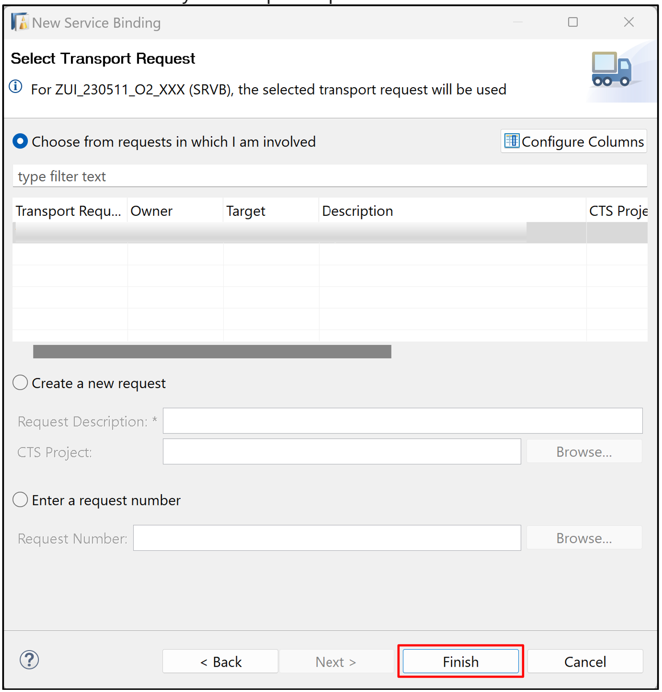

1. Activate the service binding.

step4a-activate

1. Publish the service binding.

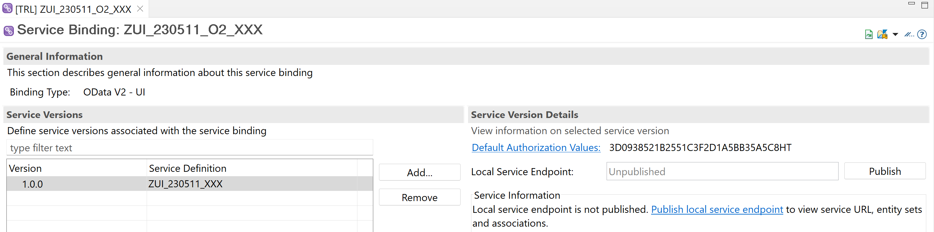No modify, close or refresh the service binding during the Publish operation.

1. Call the service.

At the end of Publishing operation the service will be ready. 